SW Concept and Design Description
DTV Service – CCS2.0

Version: 1.1 ; 01.04.2024

Status: Release

 | Date: Klicken Sie hier, um ein Datum einzugeben. | General Approval Form  [Approval Data / Link]
Distribution list  Recipients: add further stakeholders if needed | Reviewer list  Changes are announced via stages update information, no distribution as printed version,  provision in the Intranet: see footer
  Name/Department | Role in project
  Suma Anand (MS/ECR4-XC) | Project Manager
  Bharadwaj Chaitra (MS/ECR4-XC) | Component Architect
  N.N. | Safety Manager (if applicable)
  Name/Department | Role in project | Reviewer or approver
  Dasharatha Arunkumar (XC-CT/ERN4-E) | Component Product Owner | Approver
  Bharadwaj Chaitra (MS/ECR4-XC) | Component Architect | Approver
  N.N. | Safety Team (if applicable) | Reviewer
  Akash Bhasker (MS/ECR4-XC) | SW-Contributor | Reviewer
  Han Van Thi (MS/EMC23-XC) | SW-Contributor | Reviewer
  Nguyen Quoc Dat (MS/EMC23-XC) | SW-Contributor | Reviewer
  Tra Vu Anh (MS/EMC23-XC) | SW-Contributor | Reviewer

Table of content
Contents
1 List of Terms and Abbreviations 5
1.1 Annotations 5
2 Purpose of this Document 6
3 Introduction to the Subsystem 6
4 Architecture Driving Requirement Groups 7
5 Use Cases 9
5.1 Use case view 9
6 High Level Design 9
6.1 Static Software Architecture and Deployment to Domains 9
6.2 Provided Interfaces / User Handbook 10
6.3 Dynamic Design on High Level 10
6.3.1 Auto Preset 11
6.3.2 Dtv Channel Up Down 11
6.3.3 Dtv Signal Status 12
6.3.4 Dtv Channel Seek 12
6.3.5 Dtv Manual Preset Channel Store 13
6.3.6 DTV Reception Monitor 14
6.3.7 Set Physical Channel 15
6.3.8 Get Version 16
6.3.9 Test Mode Output 17
6.3.10 Get Preset List 18
6.3.11 Manual Preset Channel Store 19
6.3.12 Get Program Info 20
6.3.13 Get RMP Manufacturer ID Display 20
6.3.14 Display Banner 22
6.3.15 DTV Status Event 23
6.3.16 Get Configure 24
6.3.17 DTV Initialize 24
6.3.18 Program Information Update Event 25
6.3.19 Select Direct Channel 25
6.3.20 Set Audio Mode 26
6.3.21 Set Auto Tune Mode 26
6.3.22 Set Closed Caption Mode 27
6.3.23 Set Broadcast Search Mode 27
6.3.24 Set Event Relay Mode 27
6.3.25 Display EPG 28
6.3.26 Residential Area 30
6.3.27 Audio ES 31
6.3.28 Set Auto Broadcast Search Mode 31
6.3.29 Broadcast Search 32
6.3.30 BML Browser 35
6.3.31 EWS Event 37
6.3.32 DTV Event Update 38
6.3.33 DTV Firmware Update 39
6.3.34 DTV Module Status Notification 40
6.4 Suspend to Disk 40
7 Detailed Design 42
7.1 Static Design on Detail Level 42
7.1.1 Class interaction diagram 42
7.2 Analyzed Alternatives 42
7.3 Dynamic Design on Detail Level 42
7.4 Concurrency / Threading Model 42
7.5 Data Model View 43
7.5.1 Storage Mechanism 43
7.5.2 Data List 44
7.5.3 Configuration 44
7.6 Critical Computer Resources (CPU, RAM, Flash) 44
7.7 Install View 44
7.8 Security User and Groups 45
8 Testing & Debugging 45
8.1.1 Test Handling Implementation 45
8.2 CTS 45
8.2.1 CTS Test Cases 46
8.2.2 How to run CTS testcases 46
9 Requirements to other Components 46
9.1 Audio Requirements 46
1. Audio Focus management support 46
10 Source Code Reference 46
11 Open Points 47
12 References and Related Documents 47
13 Contacts 47
14 Amendments 47
14.1 Revision History 47

Each chapter has comments to guide the author.
This hint shall be deleted when the document will be released.
You can use “hidden text” to add information that should not be delivered to a third party. Don’t deliver Word documents, please use pdf export for that issue.

List of Terms and Abbreviations
Term or Abbreviation | Description
Component Model | In the IEEE standard 1026-1998 the component model is called the decomposition view and in RUP it is called the logical view.
Design Pattern | General approach to solve a common design problem, e.g. observer pattern. A design pattern consists of a problem statement, a solution and consequences (pros and cons).
Dynamic Model | A set of classes that work together to realize a use case, also called collaboration or mechanistic design. In the IEEE standard 1026-1998 the dynamic model is called the dependency description.
IDL | Interface Definition Language
RM | Requirement Management
State Chart | State charts are a formal behavioral language. State charts are particularly effective when the use case is reactive; that is, it has inherent states (conditions) and remains in those conditions until an event of interest has occurred. A state chart is more precise and less likely to be misinterpreted than text, but it is harder to understand. Therefore it should be used together with text and sequence diagrams.
Subsystem | An assigned area of functional responsibility
SW | Software
SWAD | Software Architecture Document
Use Case | A use case is a named capability of a structural entity in a model. Use cases organize requirements into chunks. They help to detect open requirements. It is common for a use case to represent and organize many pages of textual requirements or dozens of usage scenarios.
AAOS | Android Automotive Operating System
iAP2 | iPod Accessory Protocol version 2
USB | Universal Serial Bus
MD | Mobile Device
HU | Head Unit
SPI | Smartphone Integration
JNI | Java Native Interface

Annotations
Annotation | Description
@ASSUMPTION | This annotation at the beginning of a sentence, paragraph or statement marks the following description as something that the author assumed as true, although it is not (yet) proven.
@PRELIMANARY | This annotation at the beginning of a sentence, paragraph or statement marks the following description as something that is true at time of writing, but might change in the (near) future or still need clarification.
@TODO | This annotation at the beginning of a sentence, paragraph or statement marks something that needs to be described. Used by the author to mark open topics.
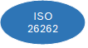
For functional safety related parts none of the annotations is allowed at time of release.

Purpose of this Document
This document is used to record results of architecture and design activities for DTV Service component on Android Systems. The document contains both the high level as well as the detailed design. It describes the behavior and how the SW interact with the remaining system. The document shows how the SW part will be arranged to satisfy the requirements and guide the developers for the implementation and maintenance phases. It also provides an understanding, which kinds of requirements are related to which design entities (such like SW components or modules).

Introduction to the Subsystem
DTV Service is a software module which is a part of the Framework Service in the android software stack. The purpose of this module is to act as a mediator between client Application and DTV HAL to provide DTV related functionalities. The audio and video rendering is not in the scope of DTV service module and is completely handled in MediaInput Service Software module.
The below diagram Figure 1 illustrates DTV Service in the Android Software Stack
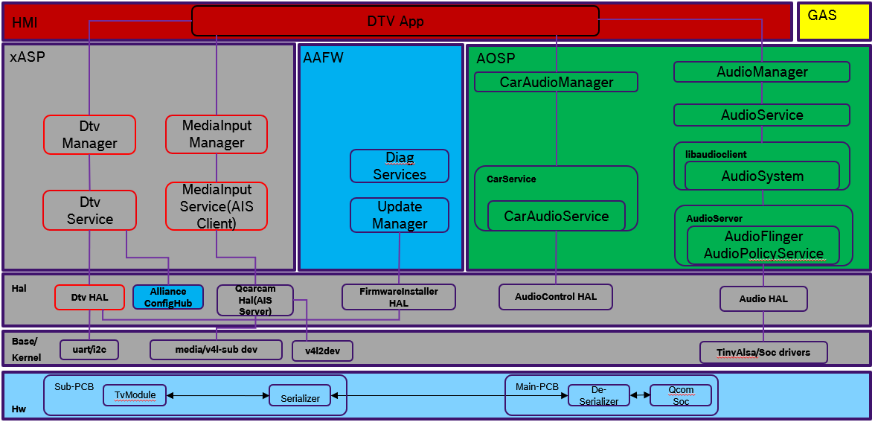
Figure 1

DTV Service provides AIDL interface for the Applications to avail DTV related functionalities. DTV Service further interacts with DTV HAL through the HIDL provided by DTV HAL.
DTV Service consists of the following
- com.bosch.service.dtv: The Service which registers with Service Manager and provides service to clients
This service hosts the below libraries
- libdtv_interface: Java Library providing the AIDL interface and DTV Manager
- libdtv_jni: JNI Library for interacting with native DTV HAL
- libdtv_modulespec: Native Library for
- Formatting and serializing the AIDL request data to DTV UART required format
- Formatting and deserializing the response and events, from DTV UART format to AIDL required format
The below diagram Figure 2 illustrates the subsystem for DTV Service.

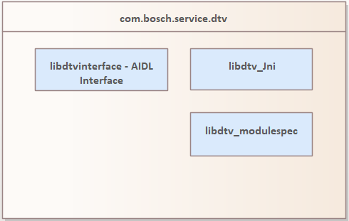
Figure 2

The more details regarding the interaction between DTV Service and other modules are explained in the later part of this document.

Architecture Driving Requirement Groups
There are two major Architecture Driving Requirement Groups for DTV Service
- DTV HAL
- Client DTV Application
Below are the major requirements fulfilled in DTV Service component.
ReqNo | Program Epic | Requirements | Details
R1 |  | [DTV] Channel Seek Up/Down
  CCS2-1617
R2 | CCS2-3554 | [DTV] Auto Preset for TV1/TV2
R3 | CCS2-3555 | [DTV] Preset List Retrieve/Update for TV1/TV2
R5 | CCS2-3557 | [DTV] Program Information Notification
R6 | CCS2-3556 | [DTV] Preset Channel Select/Store for TV1/TV2
R7 | CCS2-4631 | [DTV] Channel Up/Down (Next/Previous)
R8 | CCS2-1613 | [DTV] Antenna Phantom voltage enable
R9 | CCS2-1612 | [DTV] Audio Streaming
R10 | CCS2-3573 | [DTV] Signal Status (Weak / No signal) / No Service Notification
R11 | CCS2-3558 | [DTV] Antenna Bars Level (0/1/2/3) Notification
R12 | CCS2-3559 | [DTV] Display Banner (overlaid on TV video)
R13 | CCS2-3572 | [DTV] Direct Channel Input (3 Digits Channel Number)
R14 | CCS2-3560 | [DTV] Manual Foreground Broadcast Search (Relay/Affiliated Station)
R15 | CCS2-3561 | [DTV] Automatic Foreground Broadcast Search (Relay/Affiliated Station)
R16 | CCS2-3563 | [DTV] EWS (Emergency Warning Service) Notification
R17 | CCS2-3564 | [DTV] Initialization (TV1 / TV2 / Settings / Factory Reset)
R18 | CCS2-3565 | [DTV] TV Settings: Basics
R19 | CCS2-3566 | [DTV] TV Settings: Prefecture / Zip Code Input
R20 | CCS2-3571 | [DTV] TV Settings: Audio ES
R21 | CCS2-3567 | [DTV] TV Settings: RMP Manufacturer ID Display
R22 | CCS2-3552 | [DTV] EPG (8 Days Program Schedule for multiple channels)
R23 | CCS2-3553 | [DTV] Program Info (Detailed EPG)
R24 | CCS2-3562 | [DTV] BML Browser Remote Key Event
R25 | CCS2-3568 | [DTV] Antenna Diagnostics
R26 | CCS2-3569 | [DTV] Production Diagnostics
R27 | CCS2-3186 | [DTV] High Temperature Protection of DTV module
R28 | CCS2-3570 | [DTV] TV Module Diagnostics
R29 | CCS2-3574 | [DTV] TRMP Error Code Notification
R30 | CCS2-3575 | [DTV] Developer Test Mode (ENG Menu)

Use Cases

Use case view
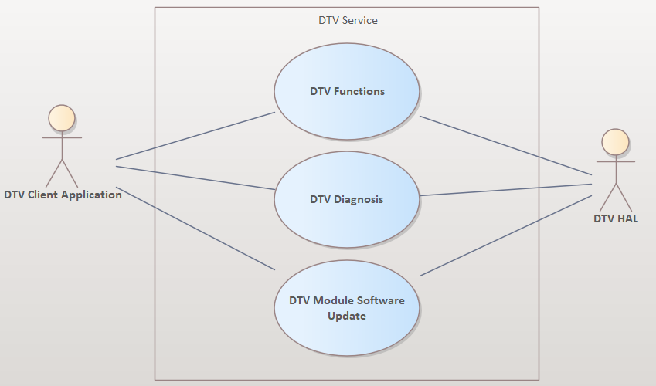
Figure 3

High Level Design

Static Software Architecture and Deployment to Domains
The below image illustrates the interaction of DTV Service with other modules in the Subsystem.

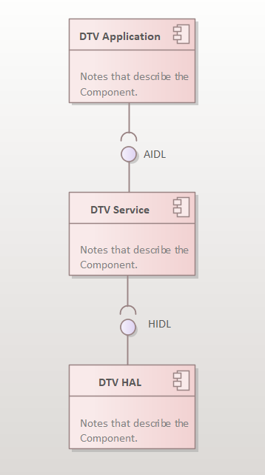
Figure 4

Provided Interfaces / User Handbook
Detailed Interface Specification and Usage details are maintained in SharePoint.
Please refer https://inside-share-hosted-apps.bosch.com/DMS/GetDocumentService/Document.svc/GetDocumentURL?documentID=P12S145423-1180436654-95

Dynamic Design on High Level
This section describes the dynamic interactions between components or subsystems.

Auto Preset
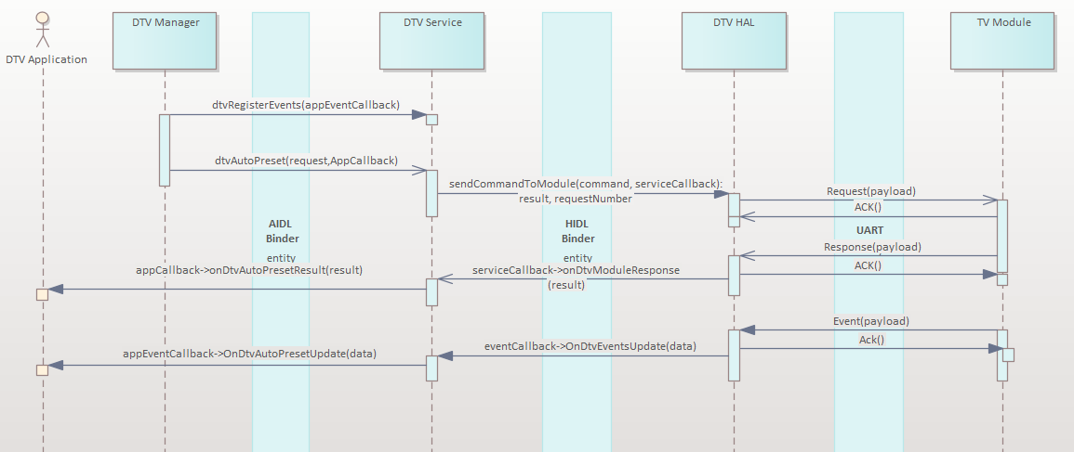
Figure 4

Dtv Channel Up Down
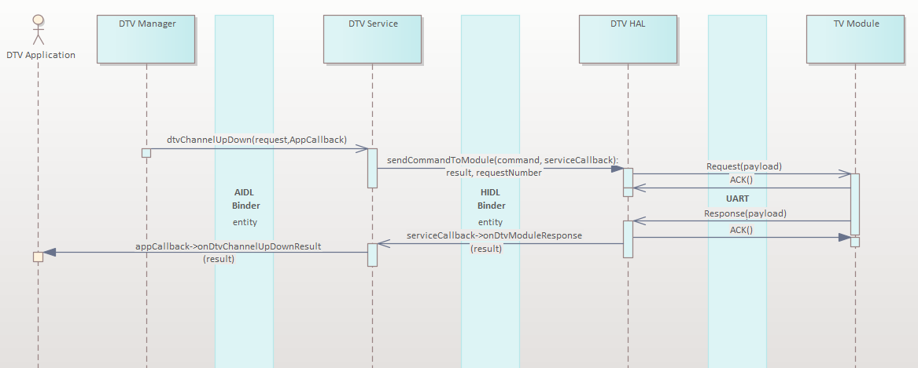
Figure 5

Dtv Signal Status
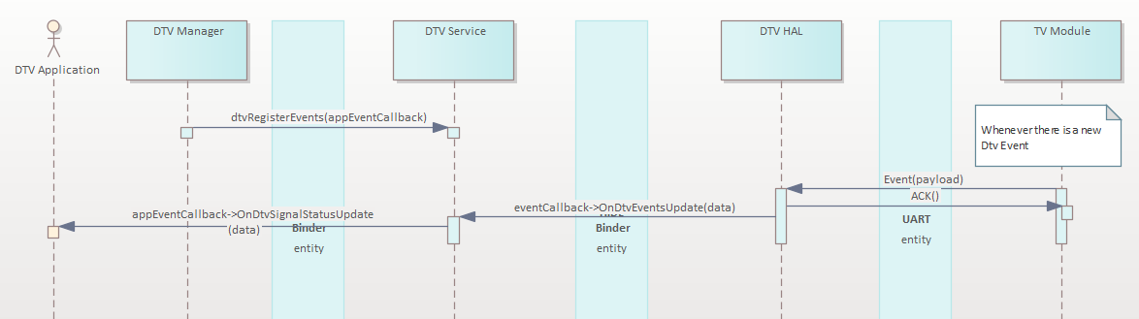
Figure 6

Dtv Channel Seek
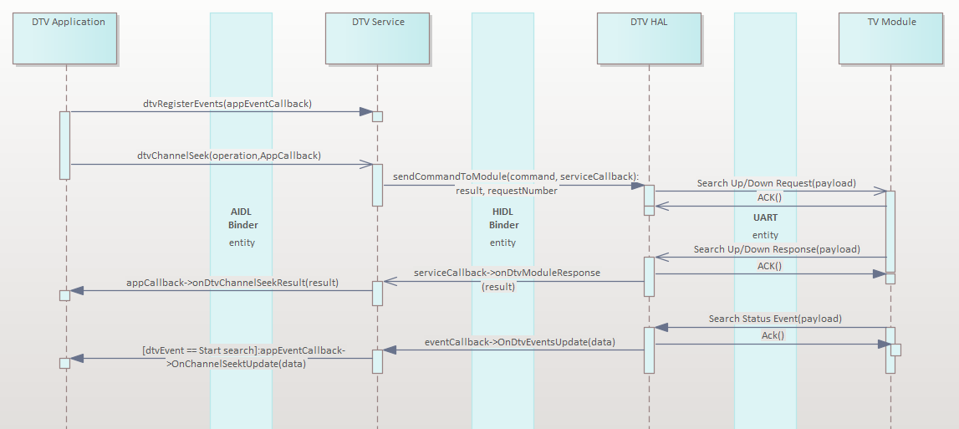
Figure 7

Search Status Update received from DTV HAL is shared for Channel Seek, Manual Broadcast Search, Automatic Search ( Foreground / Background ). The event would be notified to App through different interfaces based on the current DTV Event.

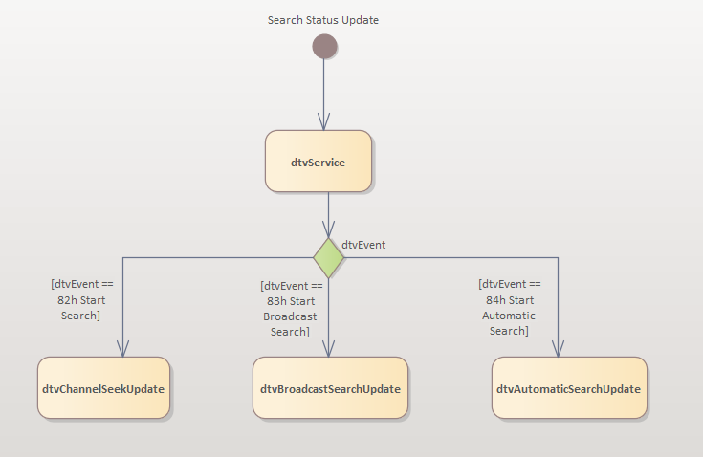
Figure 8

Dtv Manual Preset Channel Store
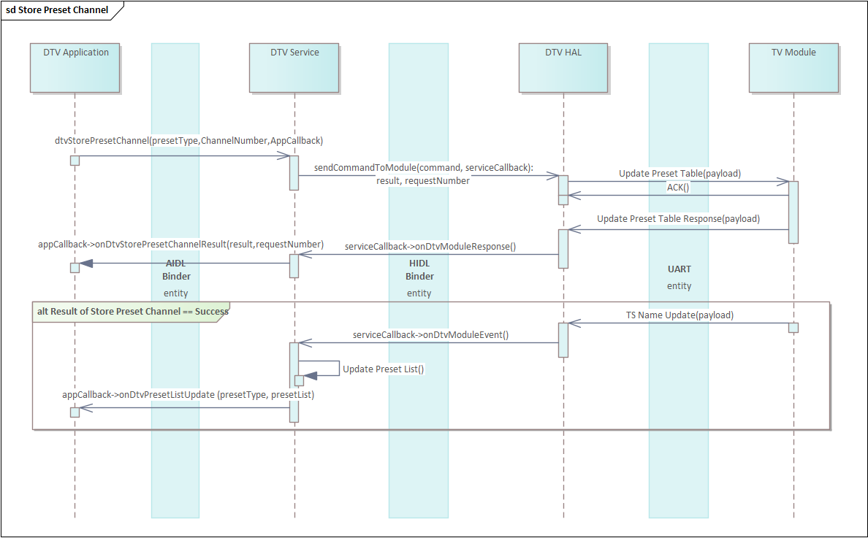
Figure 9

DTV Reception Monitor
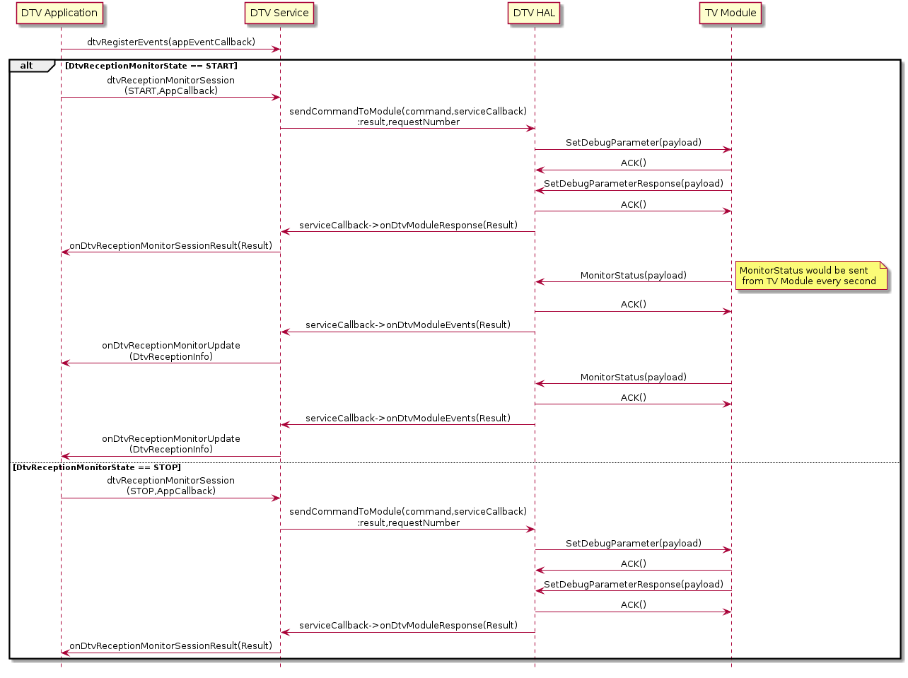DtvReceptionInfo does not provide the calculated REC value and duration since measurement started.
This has to be handled by client.

Formula for Calculation REC:
Reception rate (%) = {1- (number of data items with PER 1% or more) / (time elapsed)} x 100

Example:
User press Start in Reception Monitor Screen

1st Monitor Status update
Duration: 1s | PER | Calculated REC
Layer A | 0.6 | {1 – 0 / 1} * 100 = 100 %
Layer B | 1.1 | {1 – 1 / 1} * 100 = 0 %
Layer C | 0 | {1 – 0 / 1} * 100 = 100 %

2nd Monitor Status update
Duration: 2s | PER | Calculated REC
Layer A | 1.2 | {1 – 1 / 2} * 100 = 50 %
Layer B | 1.3 | {1 – 2 / 2} * 100 = 0 %
Layer C | 0 | {1 – 0 / 2} * 100 = 100 %

3rd Monitor Status update
Duration: 3s | PER | Calculated REC | Observation
Layer A | 1.8 | {1 – 2 / 3} * 100 = 67.33 % | Intermediate reception, some packets missed
Layer B | 1.5 | {1 – 3 / 3} * 100 = 0 % | Very Poor Reception, all packets missed
Layer C | 0 | {1 – 0 / 3} * 100 = 100 % | Very Good Reception, no or very less packets missed

Set Physical Channel
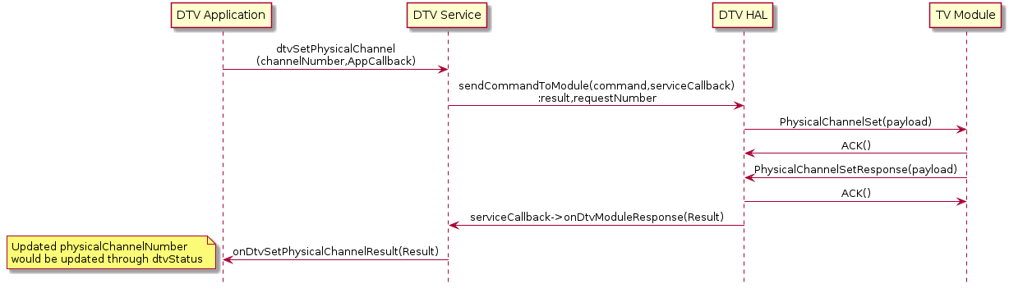
Physical Channel supported: 13 to 52
Application is responsible to send valid physical channel number.

Get Version
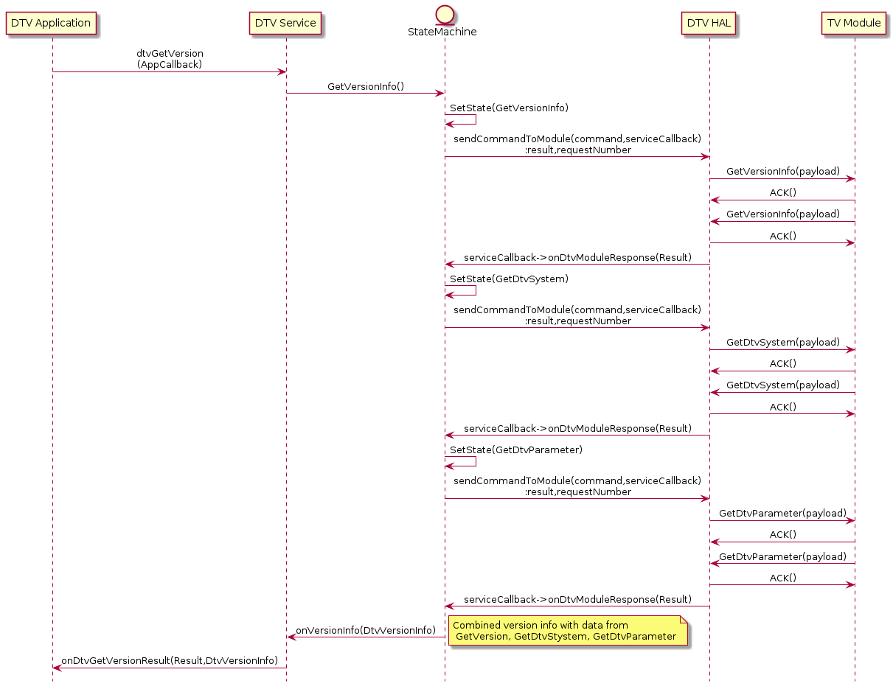
DtvVersionInfo contains information that is gathered from 3 different UART commands
String hardwareVersion; // Get Version
String bootVersion; // Get Version
String softwareVersion; // Get Version
String partNumber; // Get Part Number
String diversityMode; // Get DTV System

Test Mode Output
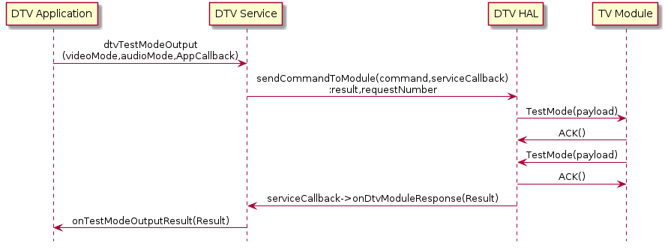

Get Preset List

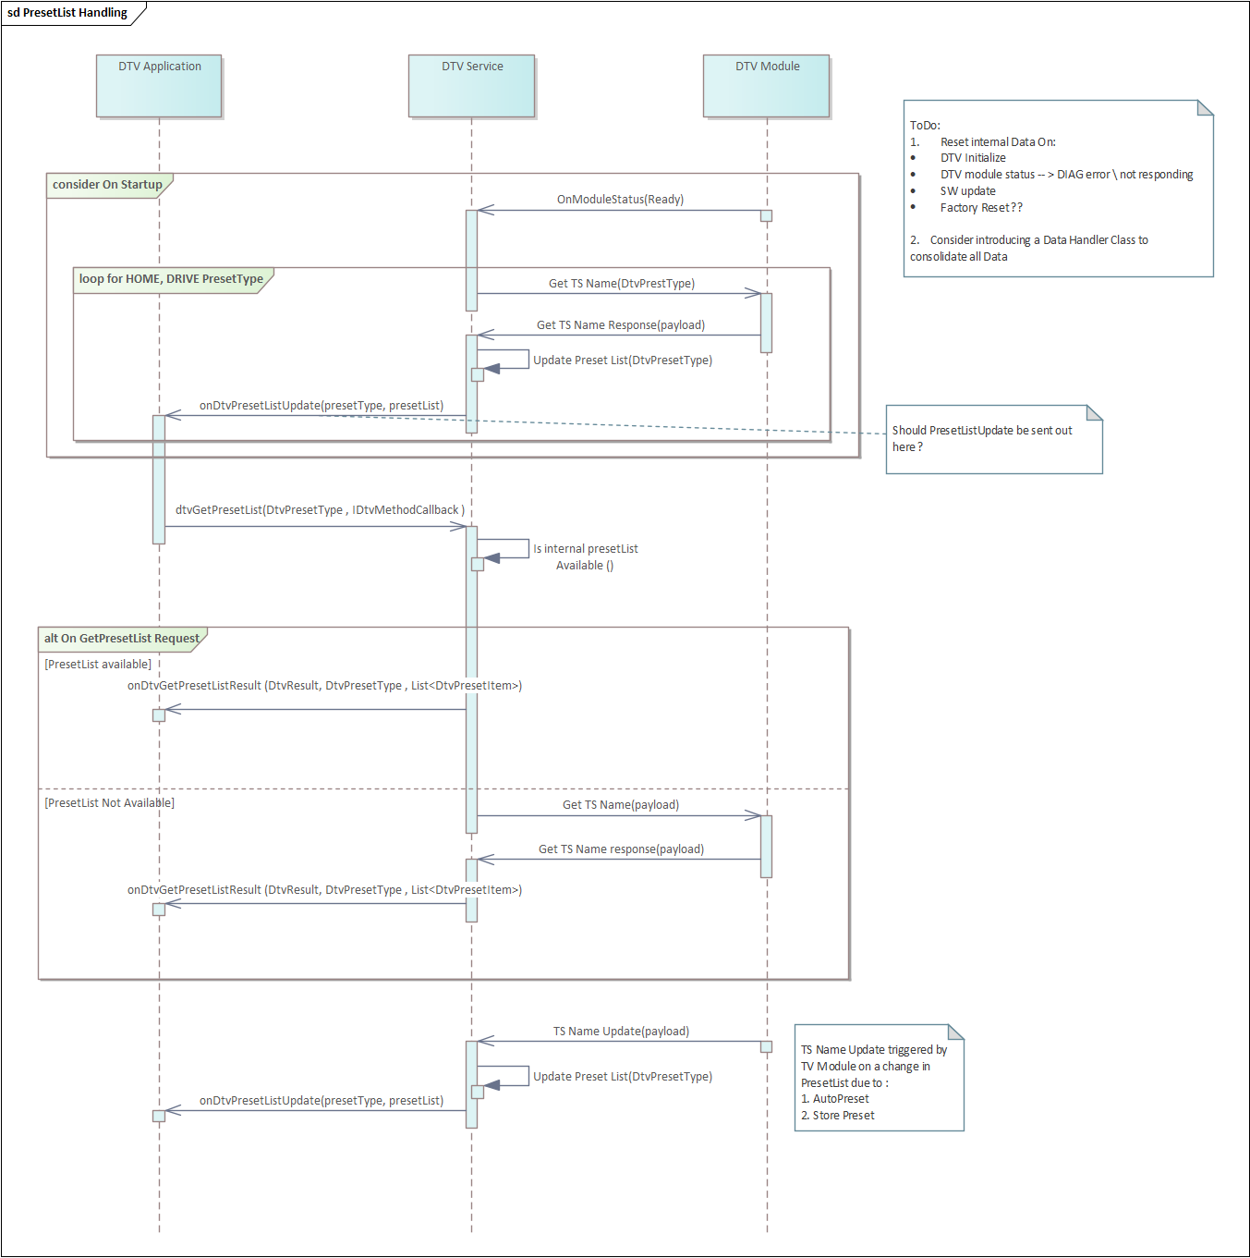

Manual Preset Channel Store

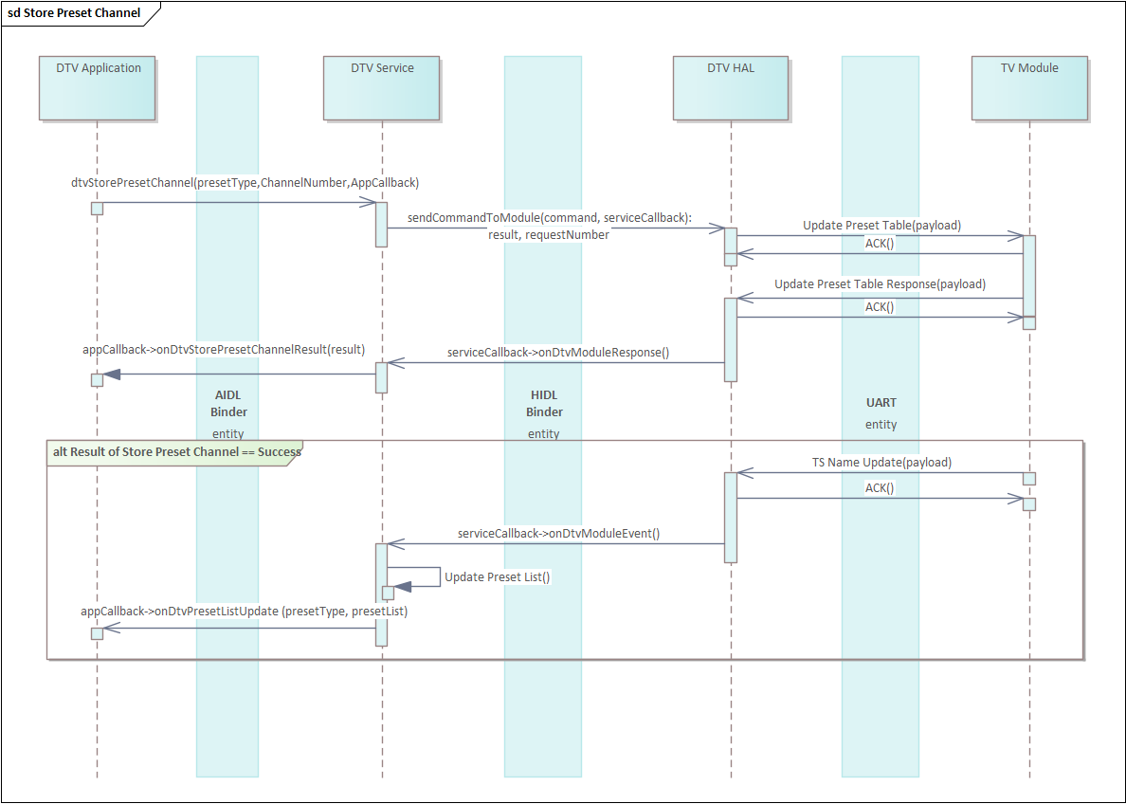

Get Program Info

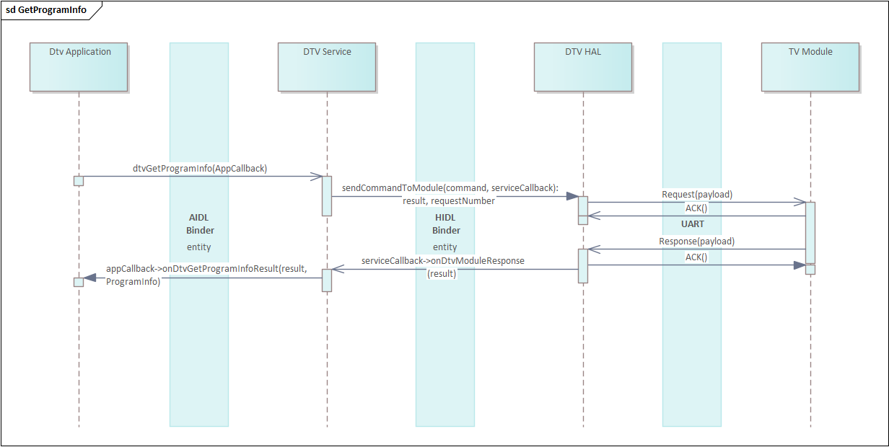

Get RMP Manufacturer ID Display
Sequence Diagram:

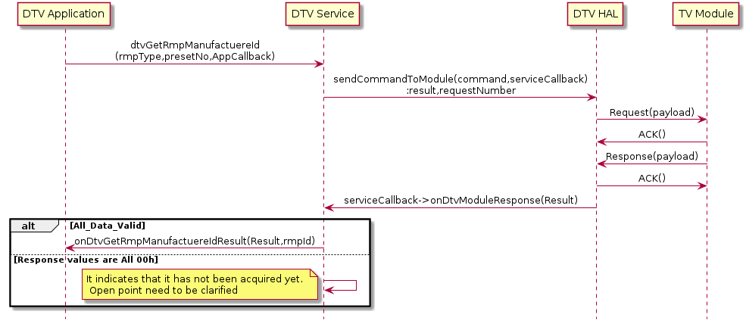

Class Diagram:

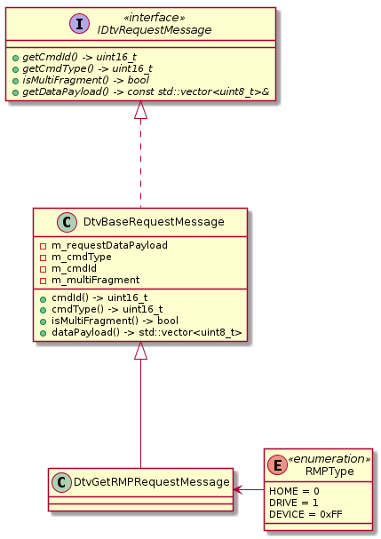

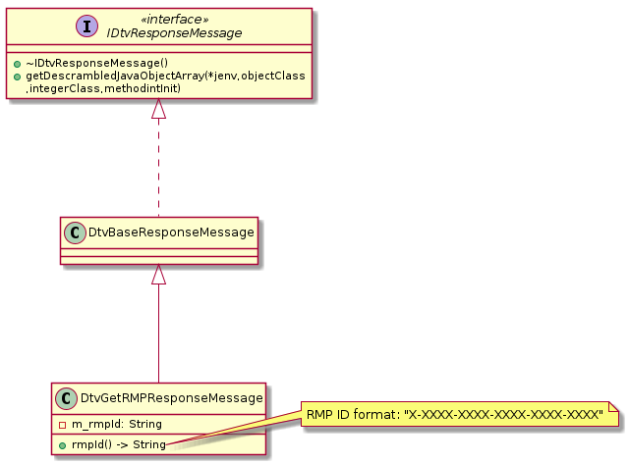

Display Banner
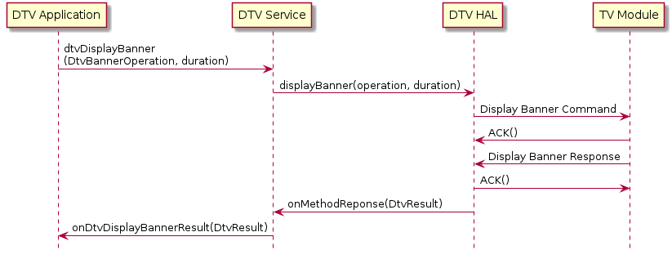

DTV Status Event
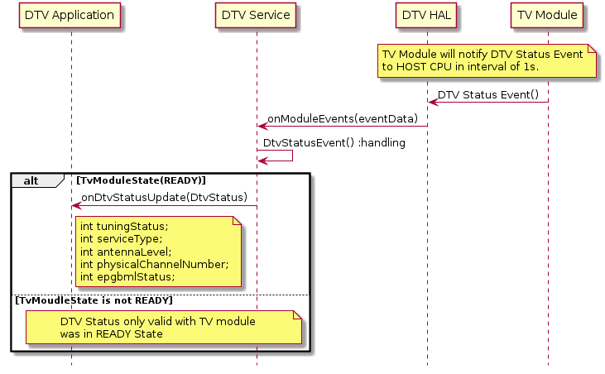

Get Configure
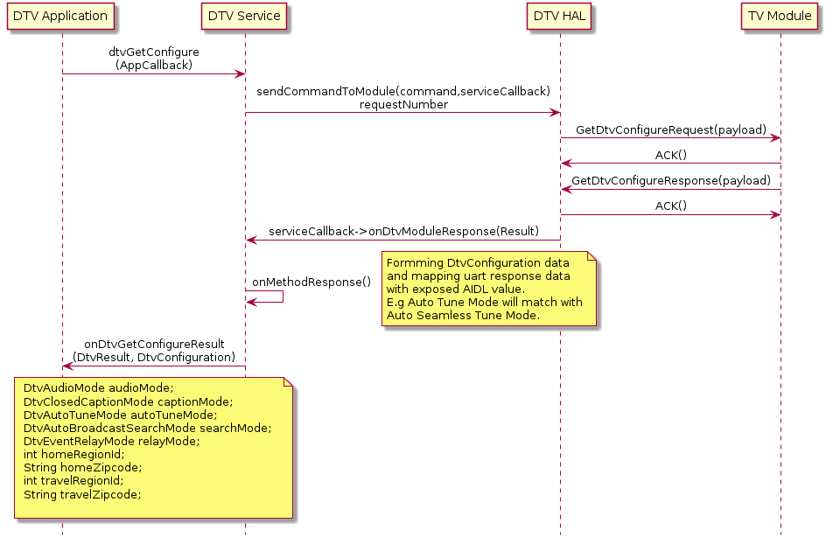

DTV Initialize
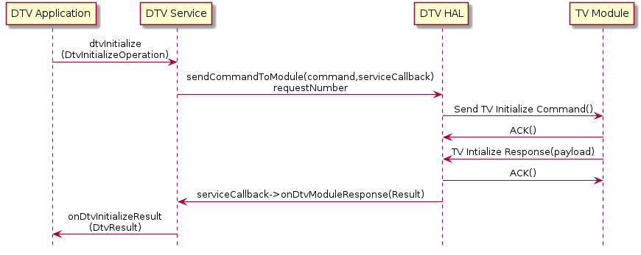

Program Information Update Event
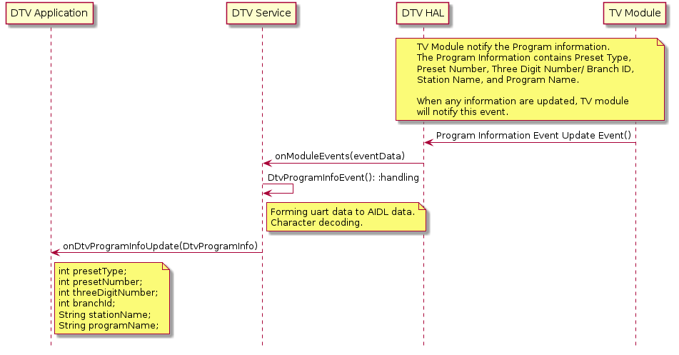

Select Direct Channel
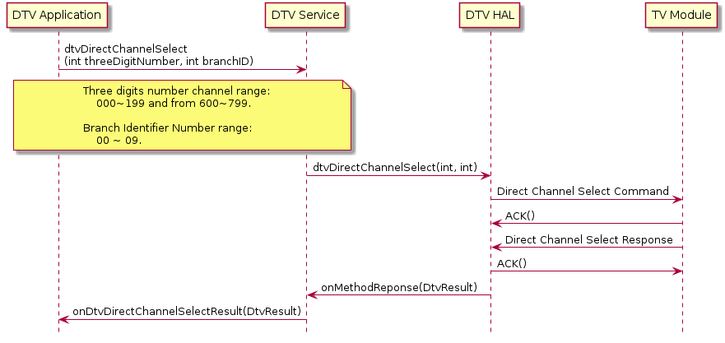

Set Audio Mode
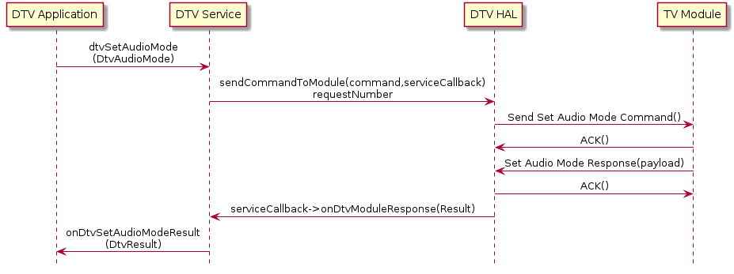

Set Auto Tune Mode
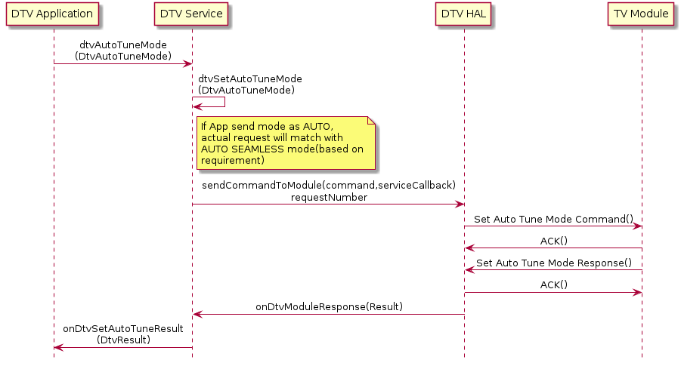

Set Closed Caption Mode
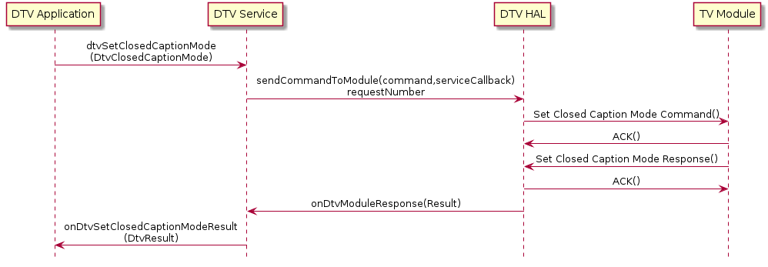

Set Broadcast Search Mode
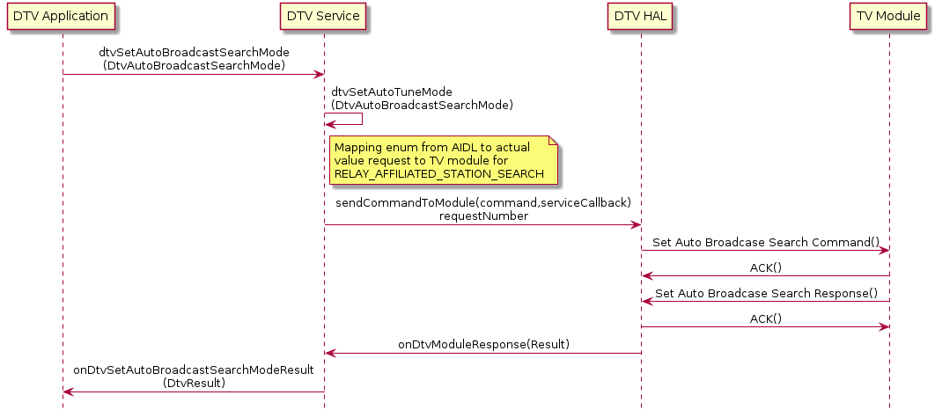

Set Event Relay Mode
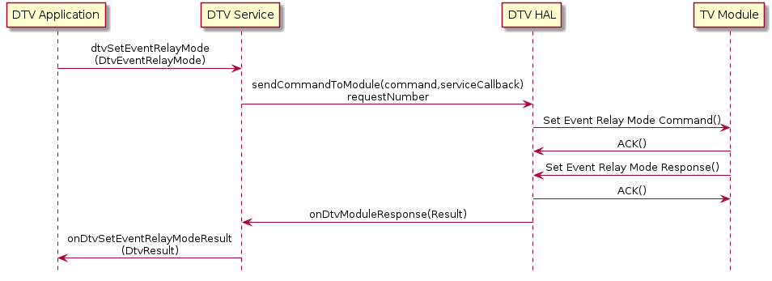

Display EPG

Current EPG sequence
- Current handling for EPG required application has to send Display EPG request again to get current EPG button status

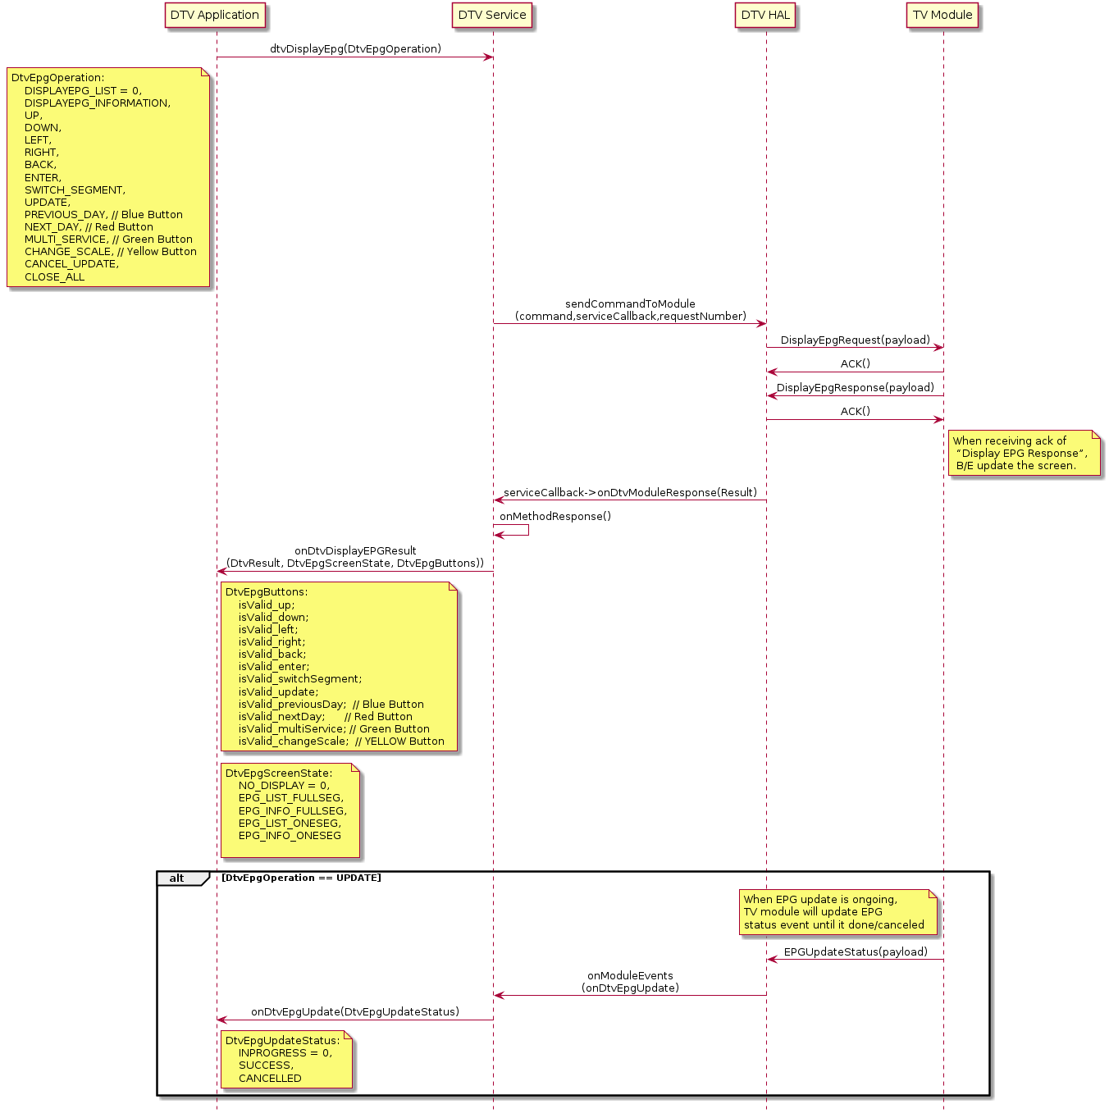

With EPG Button Status Event
- With EPG Button Status Event from TV module, application will be notified when EPG is displayed and a change in button status is required.
- As of now, this event will be disable by Event Mask, expected sequence when EPG Button Status Event enabled will be.

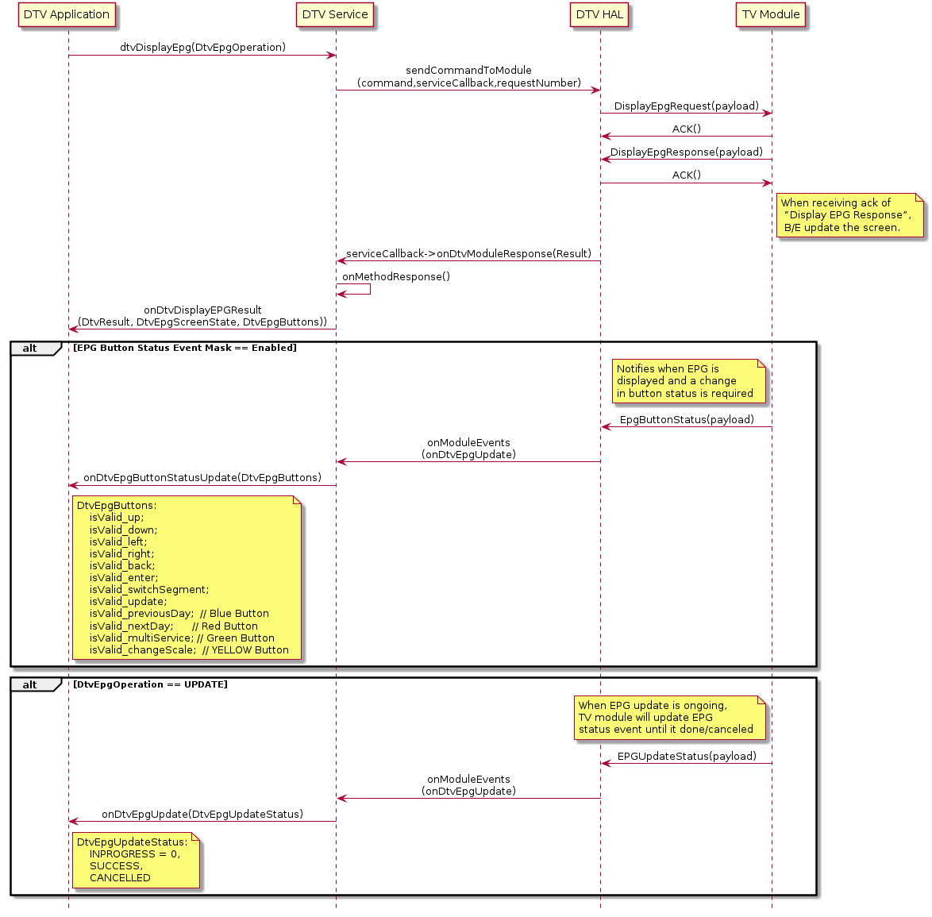

Residential Area
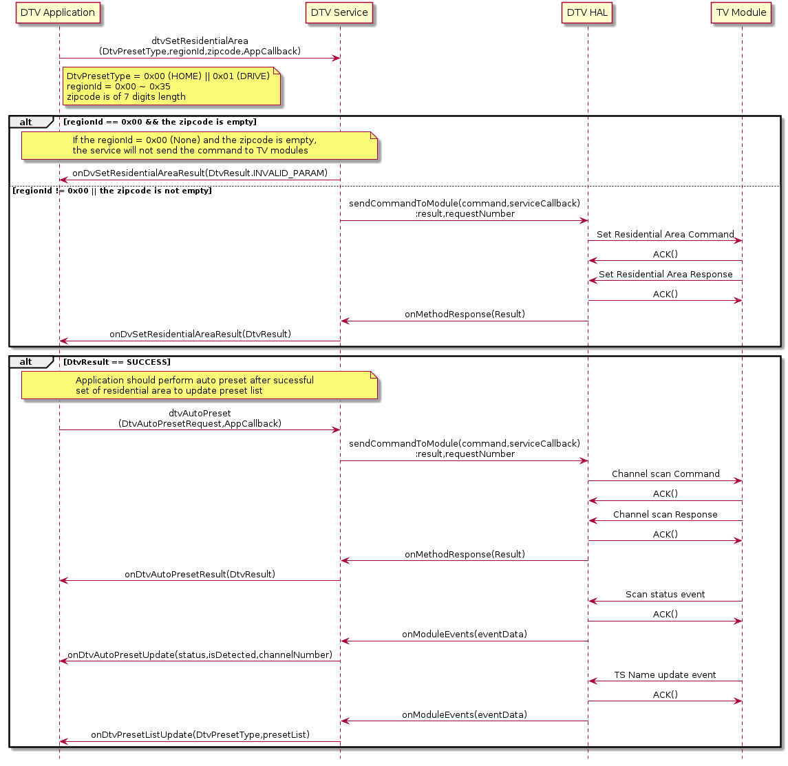

Audio ES
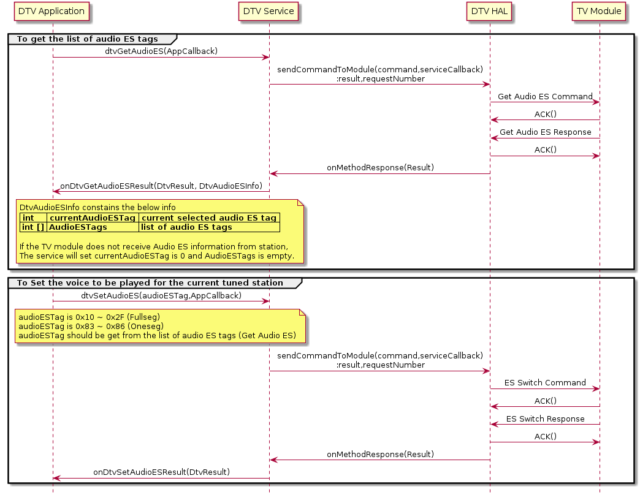

Set Auto Broadcast Search Mode
Set automatic Broadcast Search mode.
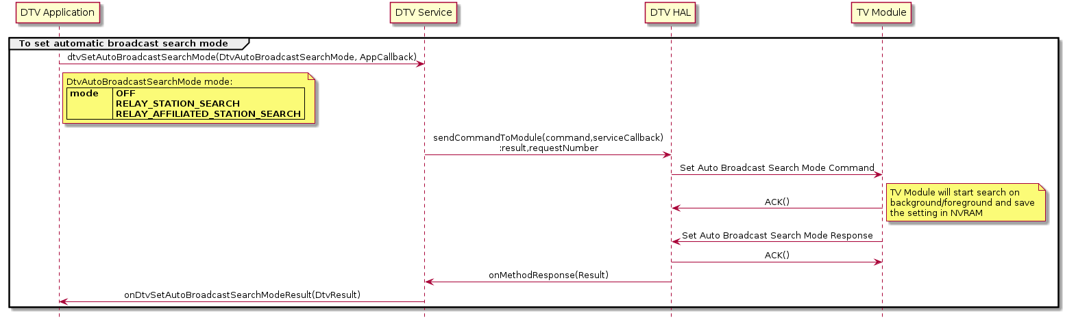

Broadcast Search
User can perform Broadcast search to
- Find affiliate / relay station / relay and affiliate / stop broadcast search (manual)
- Stop broadcast search (automatic)

Affiliated Search (Manual)
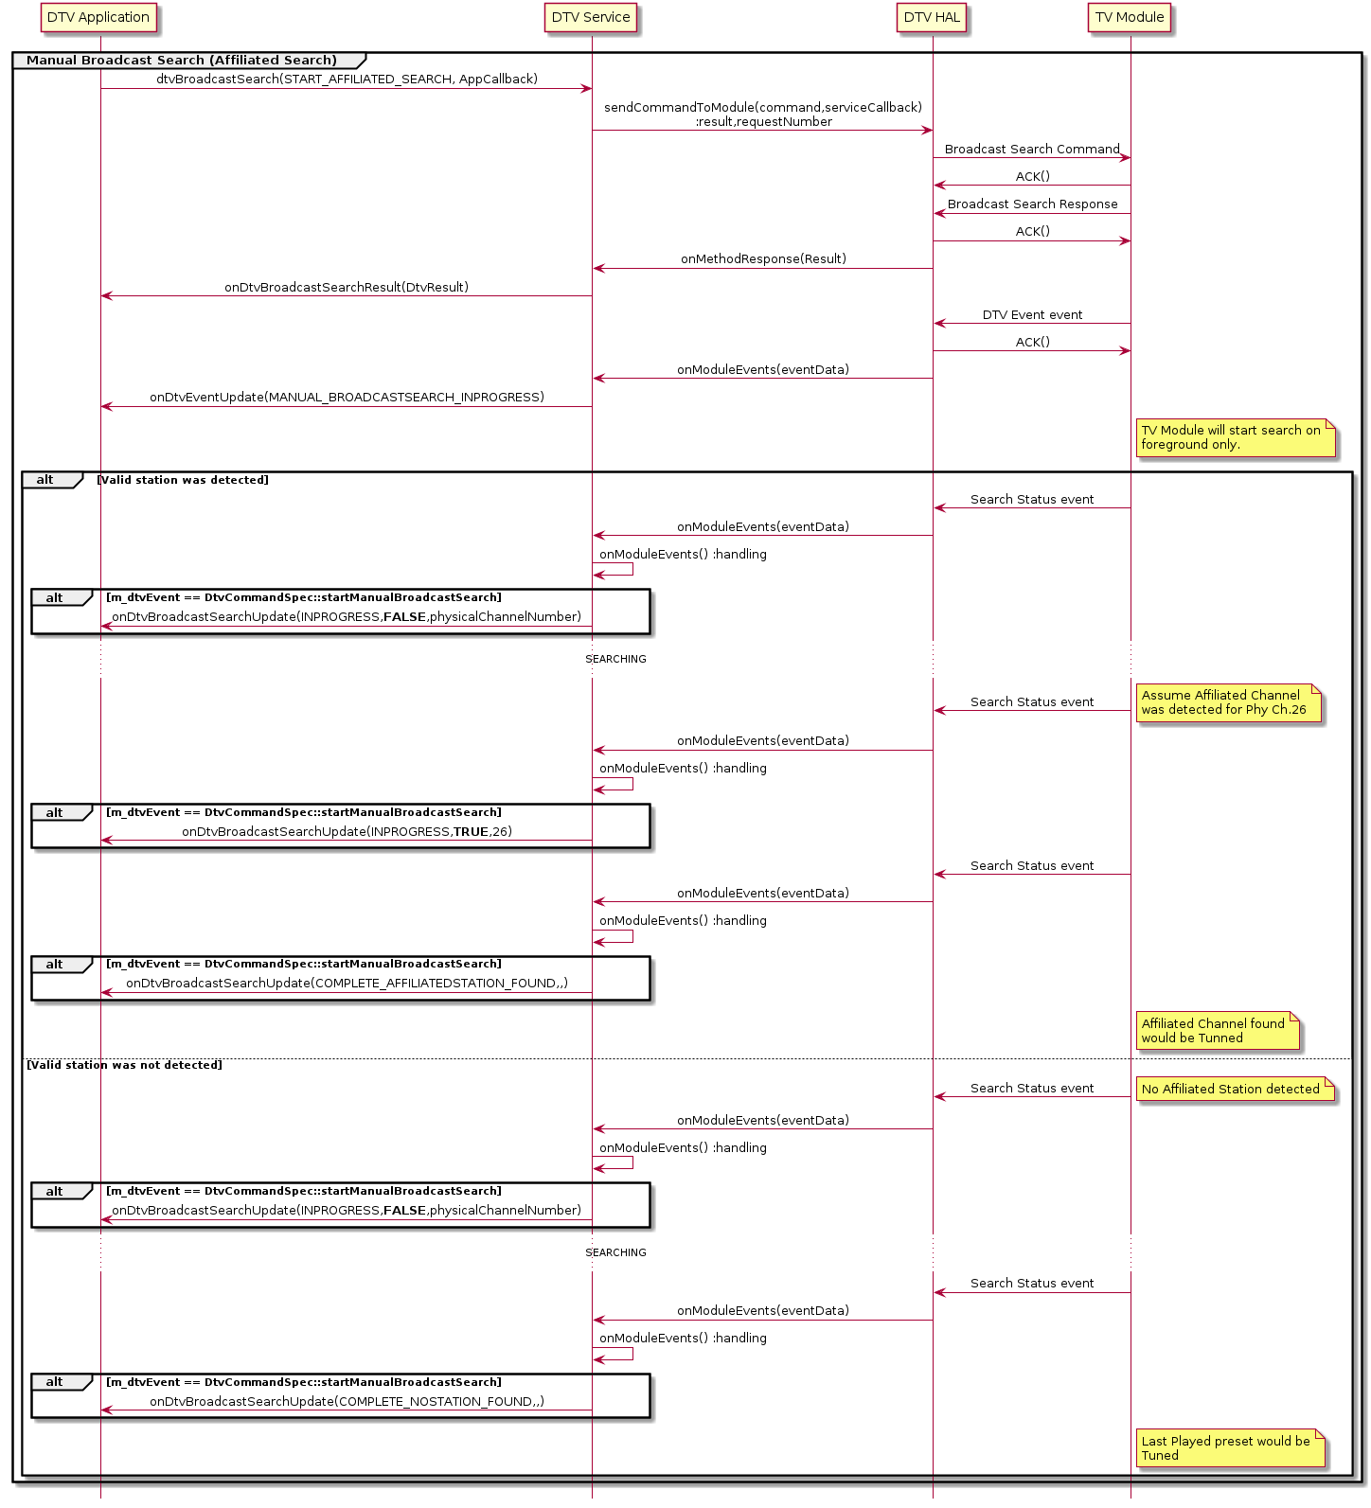

Broadcast Search (Auto)
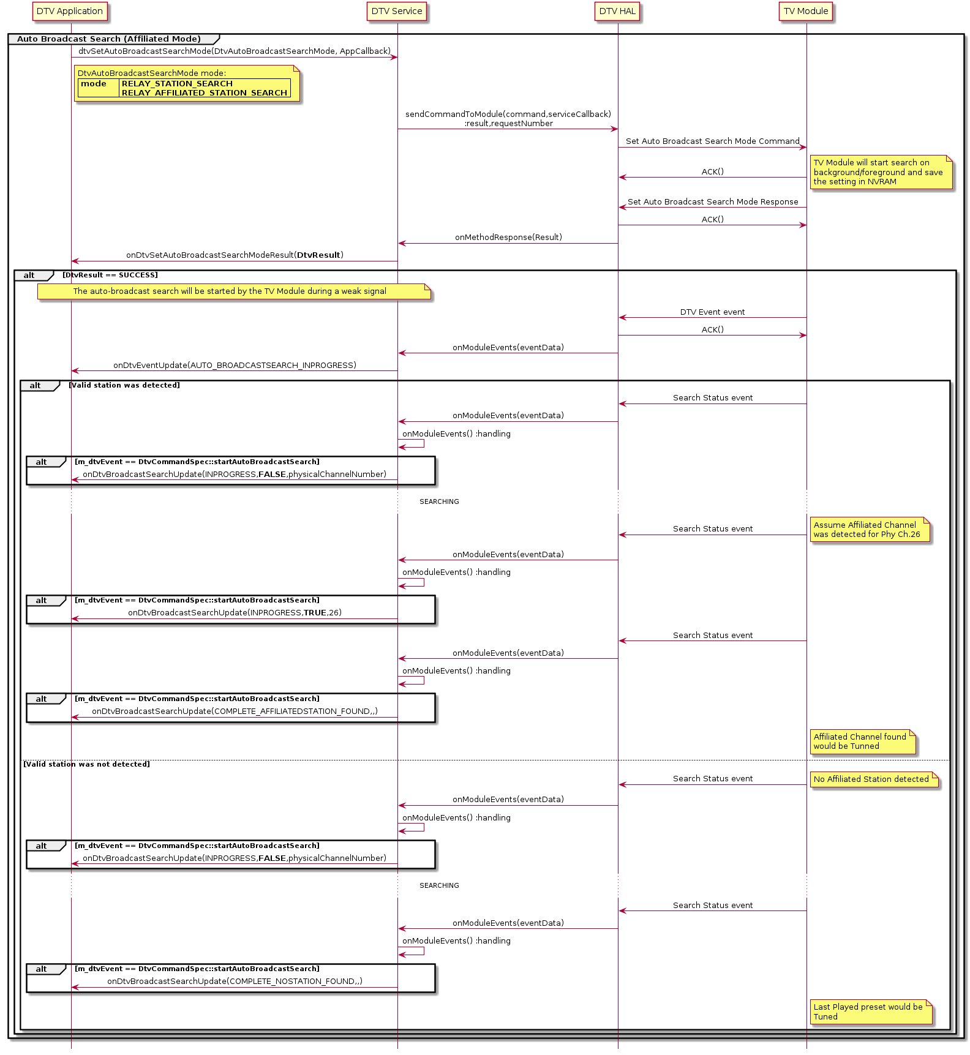

Broadcast Search Stop (Manual - Auto)
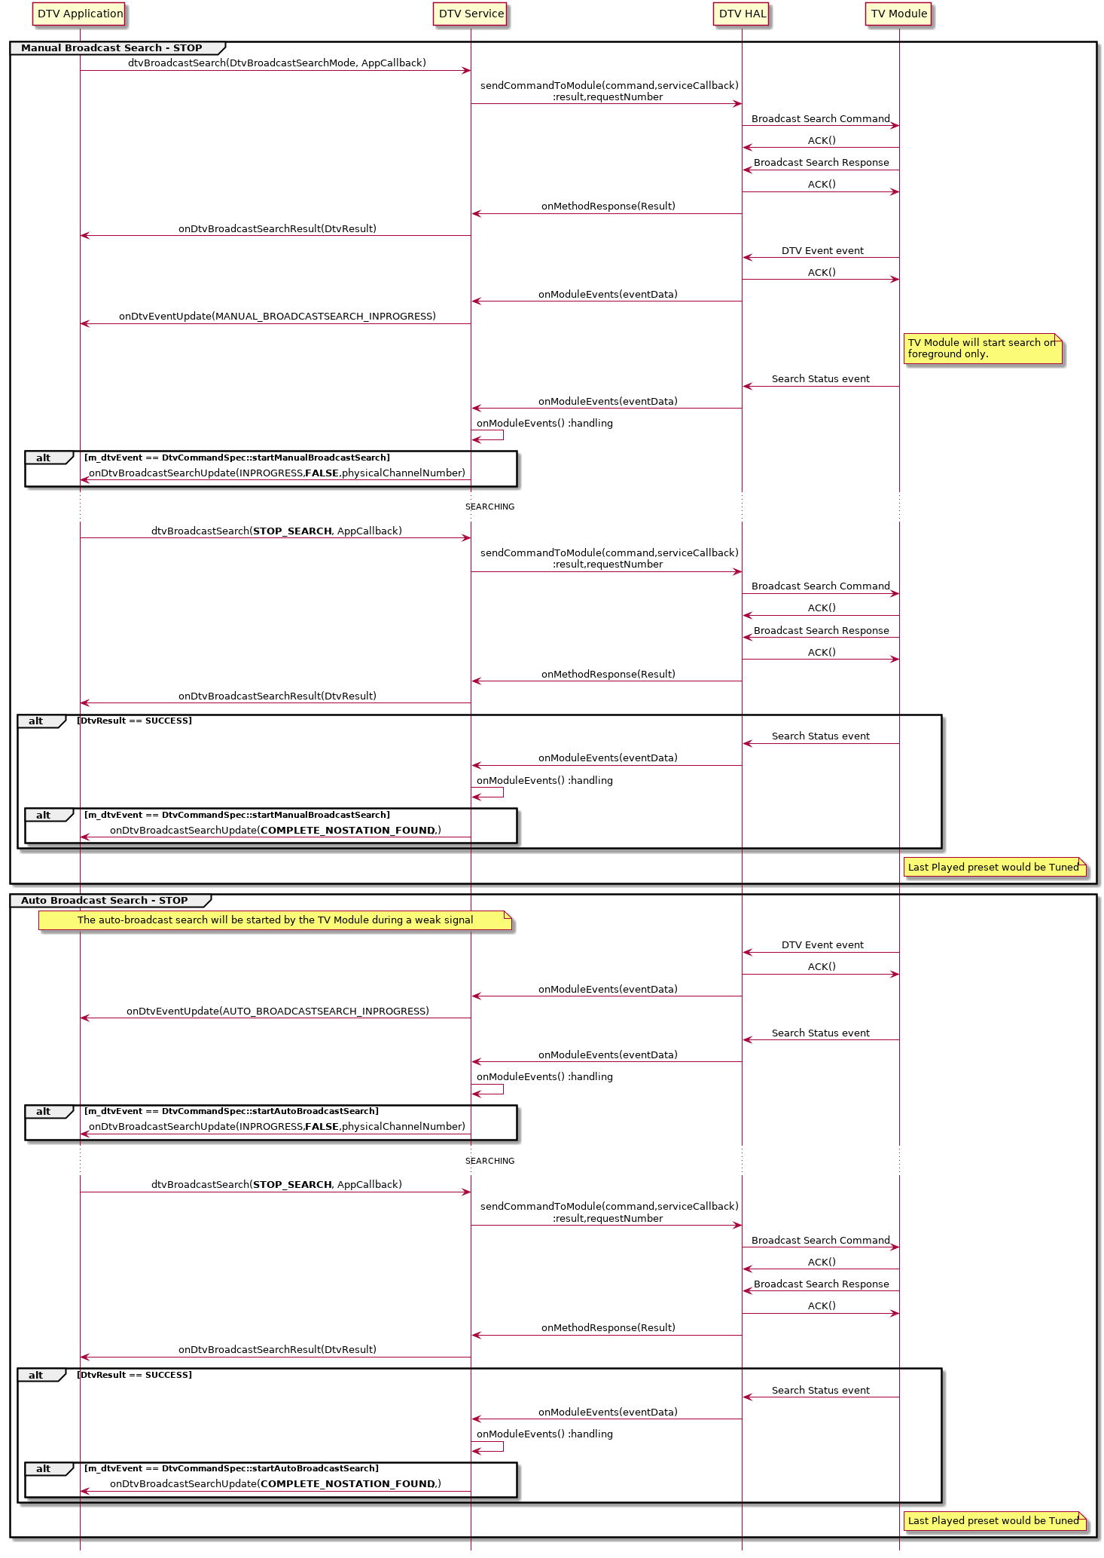

BML Browser
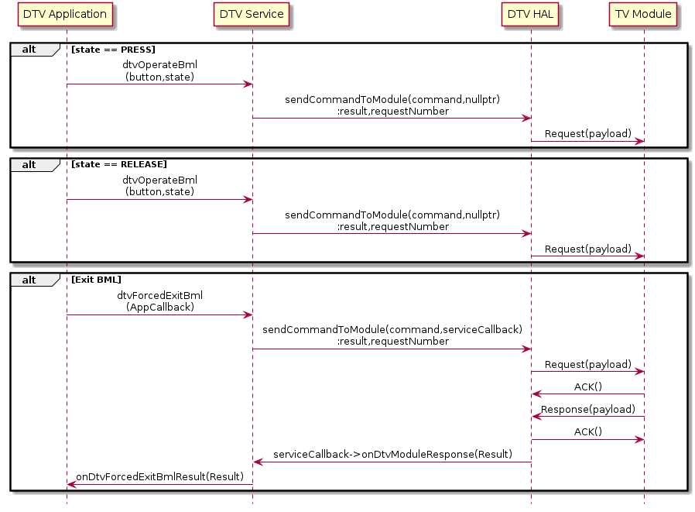

Operate BML:
User can operate BML using this interface
- There is no result provided for this interface
- Possible operations with BML which can be mapped to various buttons on remote / ‘d’ button
DtvBmlButton
NUM_1
NUM_2
NUM_3
NUM_4
NUM_5
NUM_6
NUM_7
NUM_8
NUM_9
NUM_10
UP
DOWN
LEFT
RIGHT
ENTER
BACK
DATA_BROADCAST
BLUE
RED
GREEN
YELLOW
- To start data broadcasting (on press of ‘d’ button), dtvOperateBml with DATA_BROADCAST should be used
- The successful opening of BML Data broadcast session can only be judged by the beep sound heard
- dtvOperateBml with DATA_BROADCAST would also toggle between opening BML and closing of BML.
- To close BML, dtvForcedExitBml should be used to guarantee the closure of BML Data broadcast session
- On press action of the button, application should use dtvOperateBml with relevant button and state as PRESS
- On (short/long) release action of the button, dtvOperateBml with relevant button and state as RELEASE should be used

Forced Exit BML:
Application can use this interface to ensured guaranteed closure of BML Data broadcast session
- Result would be provided through onDtvForcedExitBmlResult
- If BML Data broadcast session is open and dtvForcedExitBml sent, BML session would be closed, and SUCCESS result would be given
- If BML Data broadcast session is not open and dtvForcedExitBml sent, no action and SUCCESS result would be givenl
This interface can be used on exit of BML screen or on back button press in the BML screen (not the back button in remote)

EWS Event
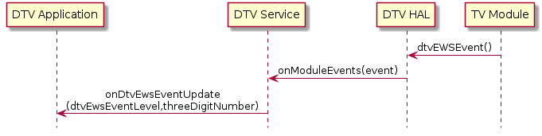

DtvEwsEventLevel
LEVEL_1 | Application should check if provided threeDigitNumber is different from the current playing threeDigitNumber (provided through onDtvProgramInfoUpdate). If yes, Application should tune to the provided threeDigitNumber using dtvDirectChannelSelect
LEVEL_2 | Application should show Emergency Warning popup to user.  If user selects “Yes”, application should check if provided threeDigitNumber is different from the current playing threeDigitNumber (provided through onDtvProgramInfoUpdate). If yes, Application should tune to the provided threeDigitNumber using dtvDirectChannelSelect
TEST
END | If Emergency Warning popup shown, application should hide the popup

DTV Event Update
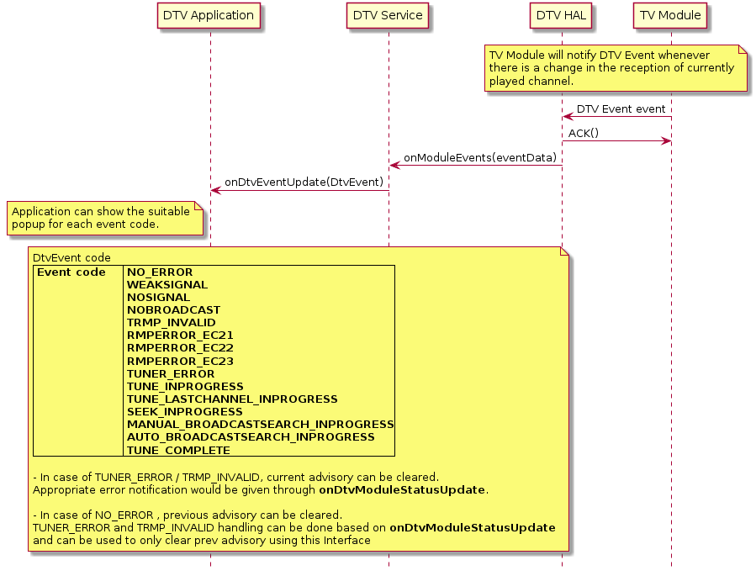

DTV Firmware Update
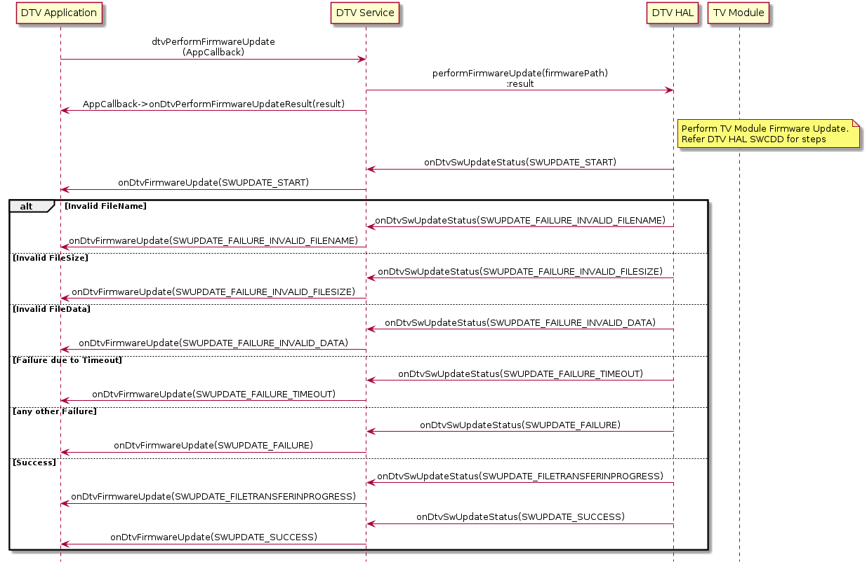

DTV Module Firmware Update sequence and state machine handling would be done in DTV HAL.
Relevant update would be provided from DTV HAL through onDtvSwUpdateStatus and the same would be notified to registered clients through onDtvFirmwareUpdate AIDL interface.

For Information related to Dtv Module Firmware update, please refer SWCDD for DTV HAL.

DTV Module Status Notification
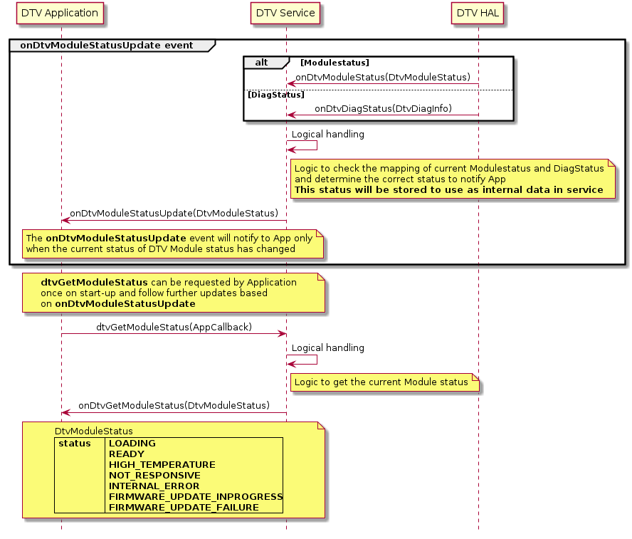
Logical Handling :
When ModuleStatus or DiagStatus is received, based on below mapping, the AIDL event
onDtvModuleStatusUpdate with the mapped values would be notified to client application.

AIDL DtvModuleStatus | HIDL DtvModuleStatus DtvDiagStatus
LOADING | POWEROFF, SHUTDOWN, LOWPOWER_MODE, MODULE_DIAG_ERROR (Without Diag error)
READY | READY
HIGH_TEMPERATURE | Temp Alert
NOT_RESPONSIVE | UART Comm, NO_RESPONSE
INTERNAL_ERROR | Operation In Service Error, TRMP
FIRMWARE_UPDATE_INPROGRESS | DOWNLOAD
FIRMWARE_UPDATE_FAILURE | ToBeUpdated

Suspend to Disk

Suspend-to-disk (S2D) is a concept to store the a snapshot of the RAM in a mass storage device (typically the eMMC / UFS). This image is loaded by the bootloader instead of doing a cold boot. The goal is to reduce the start-up time. S2D allows a complete shutdown of the device.

Dtv Service would be responsible to listen to changes in power state from android.car.hardware.power and initiate handling to both Dtv Application and Dtv Hal

Below power states are notified from android.car.hardware.power.CarPowerManager

enum | value | description
INVALID | 1 | The current power state is unavailable, unknown, or invalid
WAIT_FOR_VHAL | 2 | Enter suspend state. CPMS is switching to WAIT_FOR_FINISHED state
SUSPEND_ENTER | 3 | Wake up from suspend
SHUTDOWN_ENTER | 5 | Enter shutdown state. CPMS is switching to WAIT_FOR_FINISHED state
ON | 6 | Normal state.
SHUTDOWN_PREPARE | 7 | State where system is getting ready for shutdown or suspend. Application is expected to cleanup and be ready to suspend
SHUTDOWN_CANCELLED | 8 | Shutdown is cancelled, returning to normal state

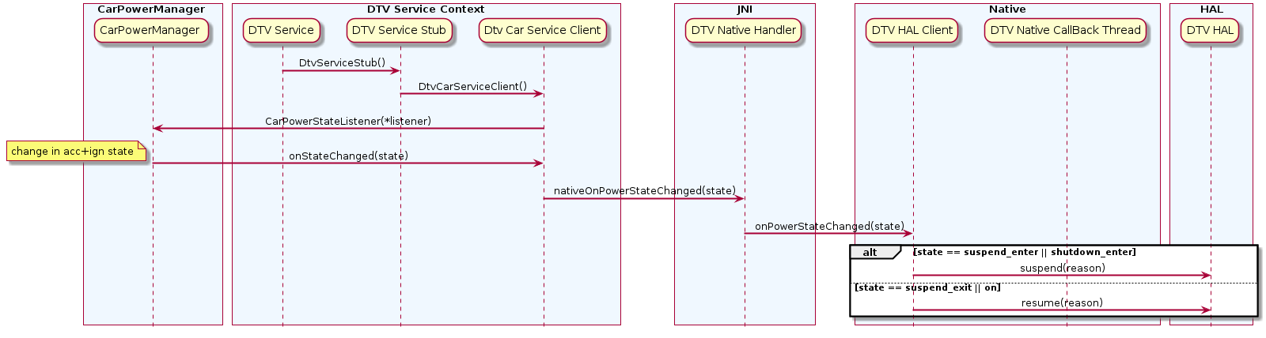

Detailed Design
This section contains details to a level needed that all important architectural decisions are taken, and the development can be started. Within these given boundaries, the developer is free to do own decisions.

Static Design on Detail Level

Class interaction diagram
The below diagram depicts the class interaction diagram.

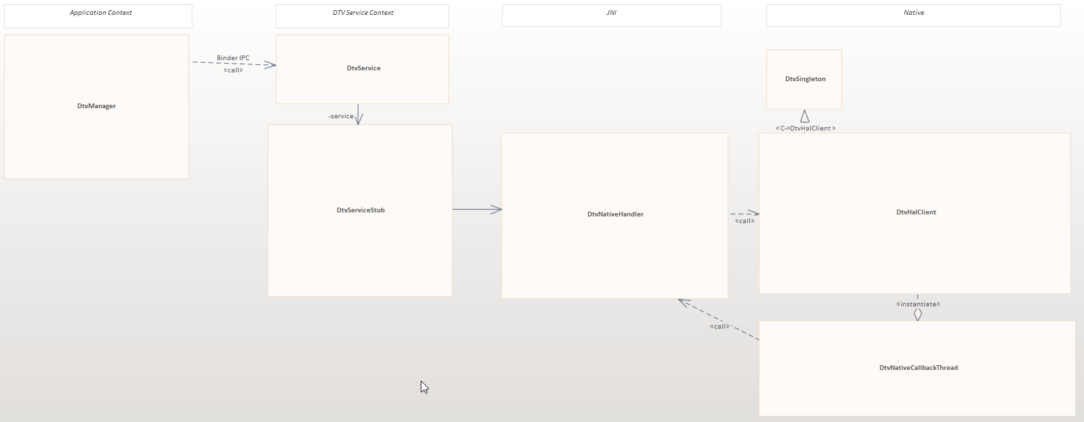
Figure 5

Analyzed Alternatives
DTV Functionality is not supported as part of standard AOSP Android Framework. Hence there were no other alternatives than to introduce a new Service to support DTV functionality. The Service is designed with the intention of supporting major business logic so that the Application can be lean. With lean application, adapting to new customers will be quicker\easier.

Dynamic Design on Detail Level
This section describes the dynamic interactions on detail level. This chapter can be skipped if the description in 6.3 Dynamic design on high level is detailed enough.

Concurrency / Threading Model
This section describes the threading model for the SW modules. In addition, a distinction is shown which threads are started within the current process space and which processes are started separately (e.g., via fork, spawn), if any.

Thread | Process space | Started by | Description incl. concurrency issues
Binder_1 | com.bosch.service.dtv
Binder_2 | com.bosch.service.dtv
Binder_3 | com.bosch.service.dtv
DtvNativeCallbackThread | com.bosch.service.dtv
HwBinder_1 | com.bosch.service.dtv
sch.service.dtv | com.bosch.service.dtv

Data Model View
This section describes the used storage mechanism (e.g., SQLite DB, data pool, …) as well as the concrete files incl. path used by the SW modules. It also describes how data integrity is secured and data can be set back to factory defaults.

Storage Mechanism
This section describes the persistence mechanisms used by the subsystem incl. the error handling (e.g., incompatible data found).

SW Module | Used Storage Mechanism

Migration of Data Structures / Error Handling
When a system is started data structures may be incompatible due to a file system corruption (bit flips) or structure change (SW update). How this expected behavior is handled by the storage mechanism is described here.

Set to Delivery State
While production test several amounts of data will be written. At the end of production, a “Set to delivery” function is called. This chapter describes how the subsystem, or SW module get the trigger of “set to delivery” and which data will be reset.

Data List
Persistent data that is in ownership of the subsystem is listed here. “Short Description” contains a brief description. “Used persistence mechanism” is a reference to 0. “Max Size” could be a static value or a formula if it is dependent on other values defined in the requirements. The “Max Size” is a prediction at design time and shall be measured after implementation to check the correctness (see chapter 6.60
Critical Computer Resources (CPU, RAM, Flash)). “When read and written” defines if the data is written on every change or e.g., only while shut down, etc. Default value explains which values are written during creation or Set to Delivery state. File System rights are the minimum needed access rights (e.g., for concurrent usage).” Deletion while SW update” describes the behavior, when a SW Update is executed (e.g., file is deleted during update or not (if not, data needs to be converted by owner at next startup if needed))

Location in flash | Short description | Used persistence mechanism (see 0) | Max Size | When read and written? | Default data | File system rights | Deletion while SW update? [yes/no]

Configuration
This section describes the configurable features/functions of the SW modules and explains the standard configuration mechanism used and the concrete values for configuring the variant. In column “Key/Value range” the key (e.g., address of KDS value) and the possible values are documented.

Critical Computer Resources (CPU, RAM, Flash)
This section describes the prediction of the CPU needs, Flash and RAM of the Subsystem.

SW Modul | CPU  [% of one ARM 9 core) | Flash  (see Data list) | Max RAM  [MB] | GPU Memory  [MB]
com.bosch.service.dtv

Install View
This section describes where the files (executables, libraries, data) of the SW module are stored in the flash file system or at other locations.

Component tag | Binary path in source | Binary path in target
libdtvinterface | out/target/product/aivi2_n_full_us/obj/JAVA_LIBRARIES/libdtvinterface_intermediates | static library
libdtv_modulespec | out/target/product/aivi2_n_full_us/obj/STATIC_LIBRARIES/ libdtv_modulespec | Static library
libdtv_jni | out/target/product/aivi2_n_full_us/system_ext/lib64/ libdtv_jni.so | system_ext/lib64/libdtv_jni.so
com.bosch.service.dtv | out/target/product/aivi2_n_full_us/system_ext/priv-app/com.bosch.service.dtv/* | system_ext/priv-app/com.bosch.service.dtv/

Security User and Groups
All needed users and groups to implement the Multi-User-Security-Concept are listed here.

Process | User | Needed groups
com.bosch.service.dtv | system | system

Testing & Debugging
Test features (e.g. automated tests, unit tests, etc.) and special test equipment needed for testing and debugging.

Test Handling Implementation

CTS
- CTS (Compatibility Test Suite) is a set of test cases and framework designed to test Compatibility
- The CTS includes the following types of test cases:
- Unit tests test atomic units of code within the Android platform
- Functional tests test a combination of APIs together in a higher-level use-case.

CTS Test Cases
- Individual test cases are executed on the DUT. The test cases are written in Java as JUnit tests and packaged Android .apk files to run on the actual device target.
- A module can contain one or more test cases. All test cases are considered individually for reporting purpose if the right template is used
- Modules can be run individually
- Each module has its own folder, somewhere within the previously shown structure.
- Each test case will generally be a function, name prefixed with @Test

How to run CTS testcases
- Trade Federation (Tradefed or TF for short) is a continuous test framework designed for running tests on Android devices. For example, Tradefed is used to run the CTS
- Trade Federation is a Java application which runs on a host computer and communicates to one or more Android devices over ADB.
- CTS test Plan can be run via the commands cts-tradefed and run cts
- Default run cts runs all the available cts testcases under every module, you can provide options to the cts run command, to run a specific module or run a specific test case from a module.

Requirements to other Components
Requirements to other components based on architecture work within this document are listed here.

Audio Requirements

Audio Focus management support

Component / Generic | Requirement

Source Code Reference
Source Directory: vendor/bosch/services/dtv

Open Points

References and Related Documents
Link | Link | Scope
 | SWCDD_MediaInput_Service | Captures Audio and Video Rendering for DTV
 | CCS2 DTV API Specification | API Spec for Interfaces to App
 | Requirement Specification

Contacts
List of persons who maintain this module as well as persons who should be asked for acceptance when the interface or the behavior of the module shall be changed (e.g., if a message format shall be changed)

No | Name | Comment
1 | Dasharatha Arunkumar (XC-CT/ERN4-E) | Product Owner
2 | Bharadwaj Chaitra (MS/ECR4-XC) | Architect
3 | Akash Bhasker (MS/ECR4-XC) | Team Member
4 | Han Van Thi (MS/EMC23-XC) | Team Member
5 | Nguyen Quoc Dat (MS/EMC23-XC) | Team Member
6 | Tra Vu Anh (MS/EMC23-XC) | Team Member

Amendments

Revision History

History |  |  | 22.12.2009 08:42:00 |  |  |  |  |  | 8093
07.12.2007 |  |  | V0003 | DRAFT | asdf |  |  |  |  |  |  | Baier
Date |  |  | Version | Status |  | Review-Minutes |  |  |  | Amendments |  |  |  |  | Author
25/01/2023 |  |  | 0.1 | DRAFT |  |  |  |  |  | Initial Version
07/02/2023 |  |  | 0.1 | UPDATE |  |  |  |  |  | Adds “DTV Module Status Notification” item |  |  |  |  | Nguyen Quoc Dat  (MS/EMC23-XC)
03/11/2023 |  |  | 1.0 | Release |  |  |  |  |  | Updated minor correction |  |  |  |  | Chaitra Bharadwaj
01/04/2023 |  |  | 1.1 | UPDATE |  |  |  |  |  | Updated DTV Status Event |  |  |  |  | Pradeep S (MS/ECR4-XC)

